**Customers list..**

”WEBSITE”-not needed when clicked on the create button it will go to add new customer page

In action there will be three button, one for view,edit and delete

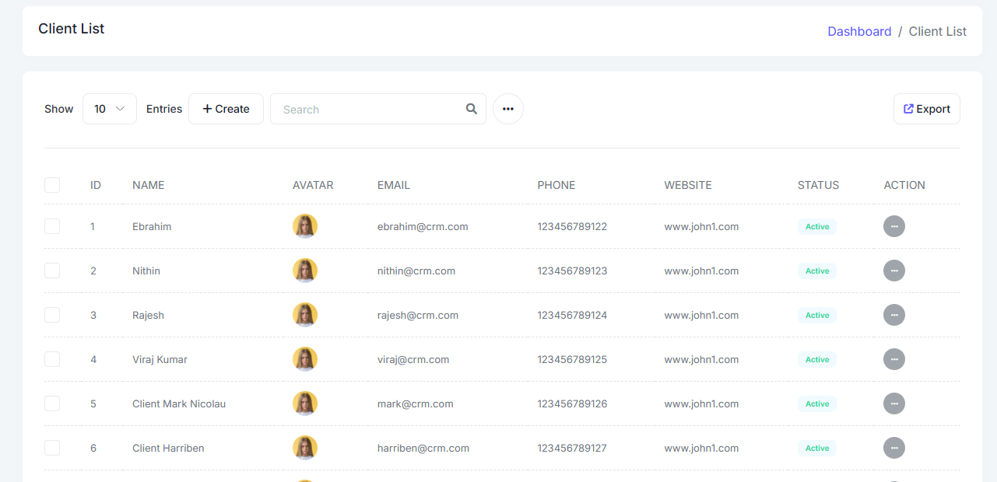

**Transaction page**

Ekhane account” lkha ta thkbena..invoice no. thkbe, reference lgbena

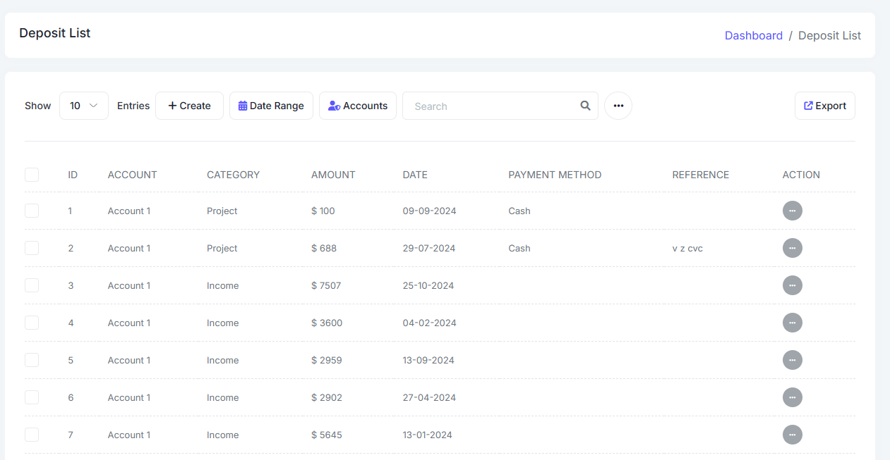

**PAYMENT DEPOSIT PAGE**

Eta hobe hocche payment deposit korar jonno..kono client er name amra tar specific order r jonno ei form r madhyome taka ta save korabo..r onar dashboard a ekhan theke show hobe..field gulo bole dicchi

POPUP hisebe ele. - First a account er jaygay client r name r id asbe jeta dynamic hobe..jei client r details a click kora hobe seta asbe..

R jodi eta single page theke kora hoy- tahle first a client id, ota select korle nam ta apnaapni asbe, tarpor amount, tarpor payment method, description, date, invoice no., attachement a invoice ta upload hobe…tarpor submit hole ota apna apni client r okhane show hobe, client invoice download o korte parbe

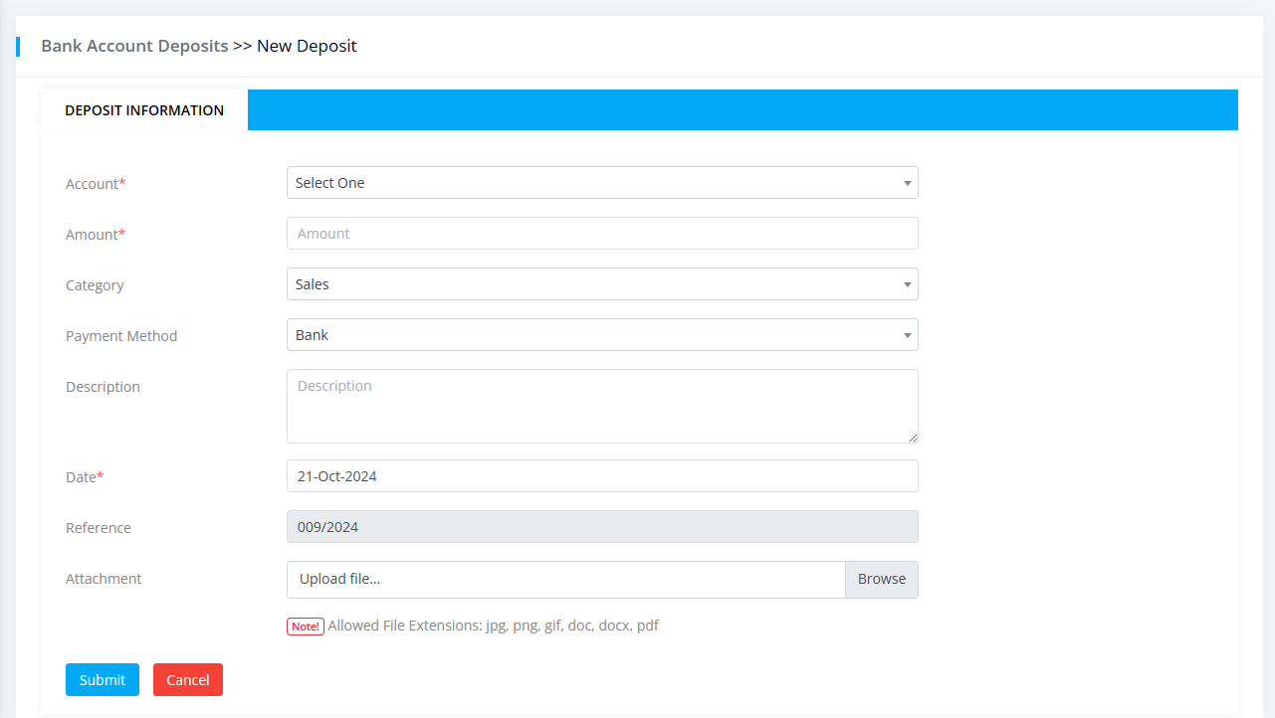

Payment method bank, cash, Net-banking ei tinta dropdown selection hobe

**QUOTATION REPLY PAGE**

jkhn amra quotation reply dite jabo tkhn ekta onyo jayga theke invoice baniye nebo and quotation r reply te oi pdf ta diye debo..client r okhane sudhu pdf show hobe..